***Crofters***

**Electrical and Electronics**

***Crofters Orbis***

**Equipment:**

* **Filter Motor-** To oxygenate the water. Should be always ON.
* **Pump Motor-** To provide nutrients to the plants from the wastes produced by fishes in the fish tank. Should be ON for 45-90 seconds every 10-15 minutes.
* **Grow bed LEDs-** To favour the growth of plants in primary grow bed as a replacement for sunlight. Brightness has to adjustable.
* **Seedling Light-** To favour the growth of plants in primary grow bed as a replacement for sunlight.

***School System***

* Completely **offline** system.
* All equipment are controlled by **switches.**
* Brightness of grow bed LEDs are fixed at maximum brightness.
* A PCB with **timer circuit** controls the cycling of Pump Motor.

**Wiring**

**Components Required:**

1. 1x 3-pin AC Plug
2. 4x Switches
3. 5x Female Sockets
4. 2x Male Sockets
5. Equipment:
   1. LED Strips
   2. SMPS
   3. Filter
   4. Pump Motor
   5. Seedling Light
6. DC Adaptor
7. PCB
8. USB Cable
9. Switch Box
10. Wires and Tools

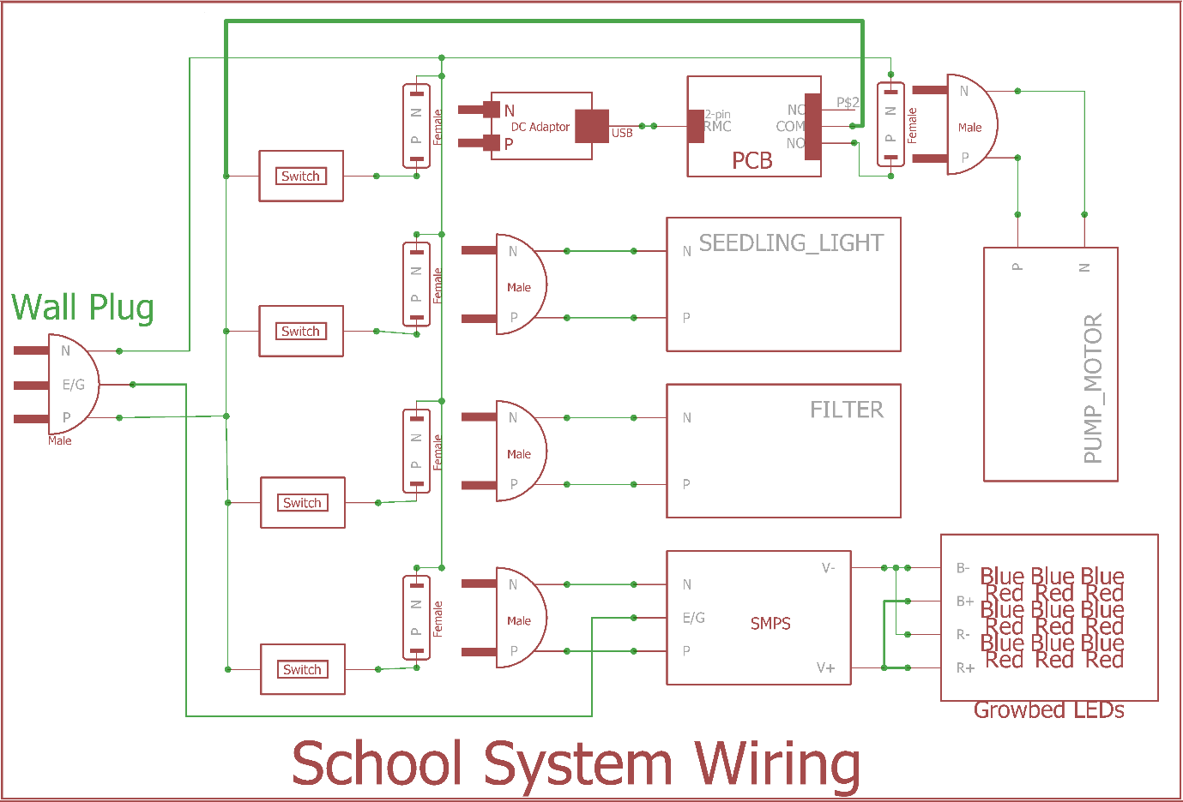

Switch for filter is kept inside while other switches are kept outside.

**PCB**

It contains the circuit for controlling the timing cycle of the pump motor.

**Components:**

1. Copper Clad Board(8 cm x 2.5 cm)
2. AtTiny45
3. 8-pin IC Socket
4. 5v Relay
5. 10k Resistor
6. 0.1uF Capacitor
7. 1N4007 Diode
8. Q2N222 Transistor
9. 2-pin RMC
10. 3-pin Screw Terminal
11. Etching, Drilling and Soldering Tools

**Circuit Diagram**

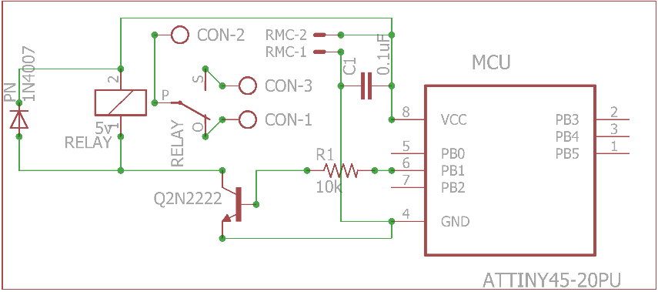

**PCB Layout**

**Top Layer Bottom Layer**

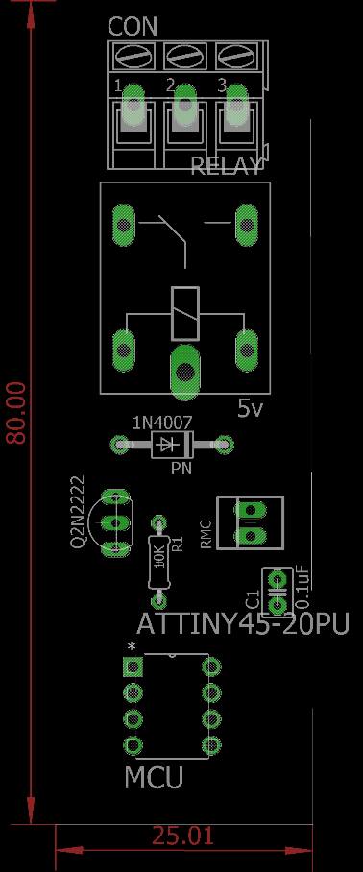 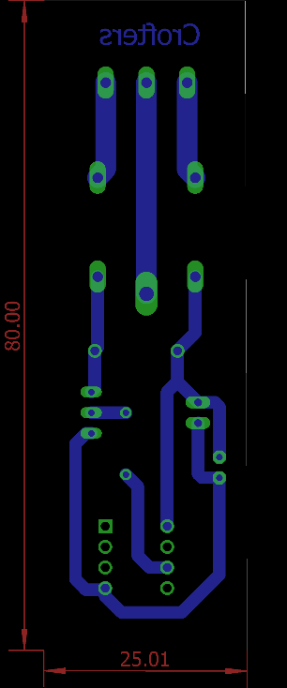

***Home System***

* Completely **online** system.
* All equipment except Filter are controlled by **mobile app** or **web app.** Filter is controlled by a switch.
* Brightness of grow bed LEDs are variable.
* A PCBcontrols the working of the entire system.

**PCB Version History**

**V1.0:**

Used Node MCU. Filter was controlled through app. IRF540N MOSFET was used to control the LED brightness.

**V2.0:**

Wemos was used instead of Node MCU to reduce board size and cost. Used polygon copper pouring on entire PCB to fasten etching process**.**

**V3.0:**

Arcing occurred on V2.0. Copper pouring was applied only on DC part of the board.

**V4.0:**

Arcing occurred on V3.0 due to closely routed lines. Hence the board was re-routed manually.

**V5.0:**

LEDs are used to indicate the Wi-Fi connectivity. Ultrasonic Sensor was used in 3-pin configuration.

**V6.0:**

Ultrasonic sensor didn’t work properly in 3-pin configuration in V5.0. So it is used in 4-pin configuration. Filter is controlled by switch which resulted in the removal of one relay. IRLB8748 is used instead of IRF540N. IRLB8748 works better than IRF540N.

.

**Wiring**

**Components Required:**

1. 1x 3-pin AC Plug
2. 1x Switch
3. 5x Female Sockets
4. 2x Male Sockets
5. PCB
6. Equipment:
   1. LED Strips
   2. SMPS
   3. Filter
   4. Pump Motor
   5. Seedling Light
7. DC Adaptor
8. Sensors:
9. Ultrasonic
10. DHT11
11. USB Cable and OTG Cable
12. Switch Box
13. Wires and Tools

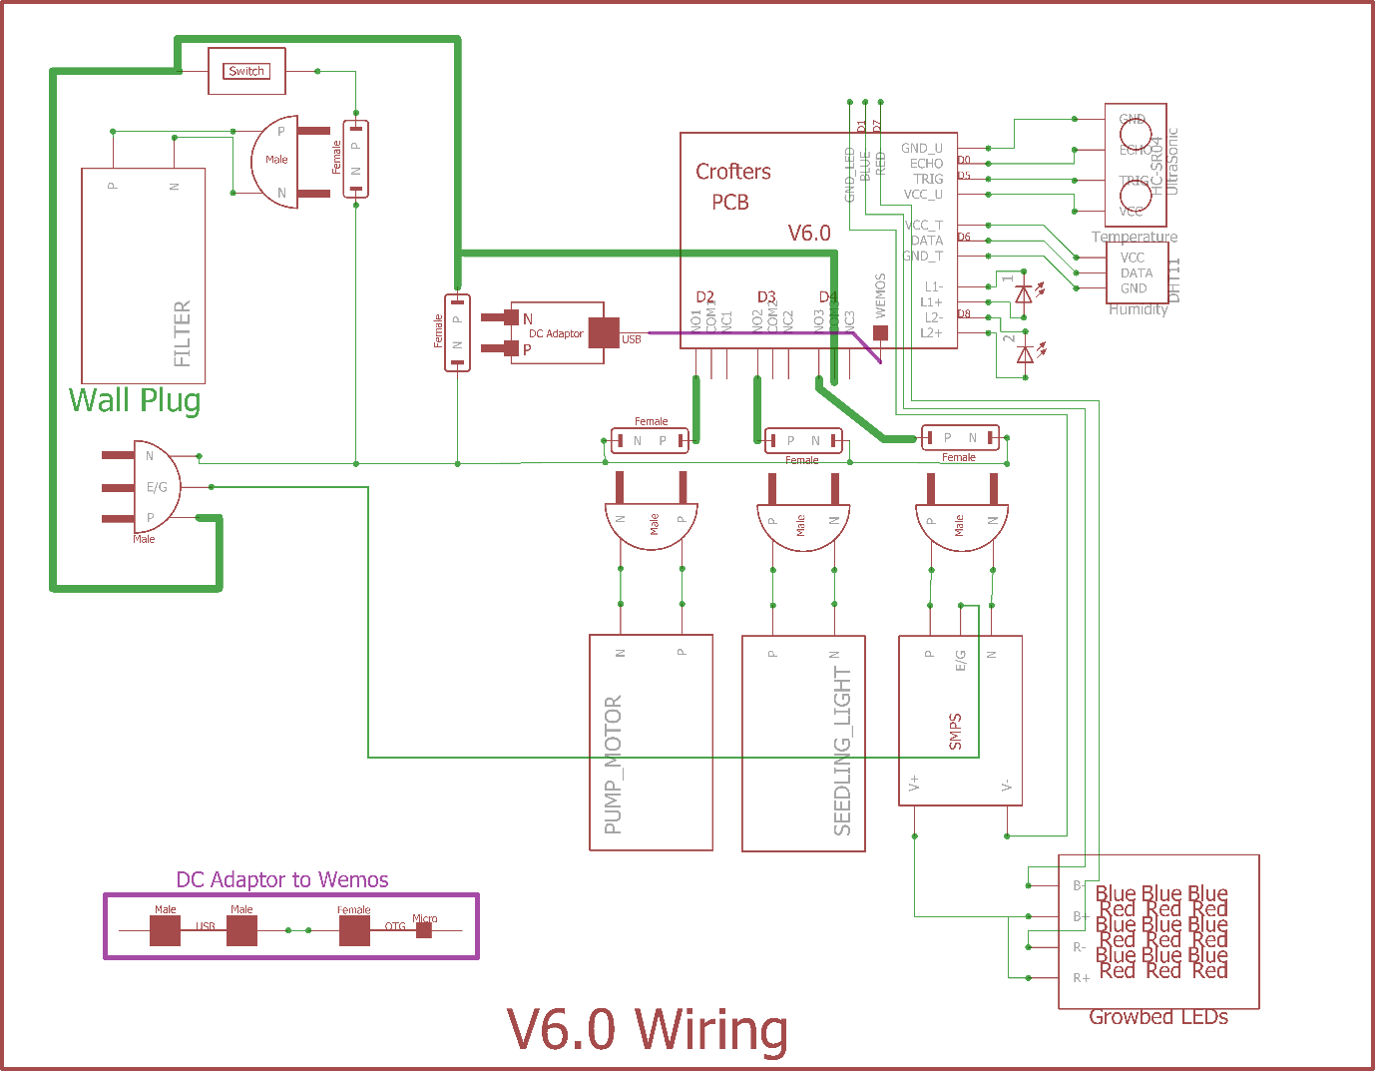

Switch for filter is kept inside. Sensors are connected using ribbon wires.

**PCB**

It contains the circuit for controlling the entire system using mobile or web app.

**Components:**

1. Copper Clad Board(14 cm x 6.5 cm)
2. Wemos D1 Mini
3. ULN2003AN
4. 3x Relay (5v)
5. 5v Relay
6. 3x PN Diode (1N4007)
7. 100 Ω Resistor
8. 2x MOSFET (IRLB8748)
9. 4x 3-pin Screw Terminal
10. 16-pin IC Socket
11. 2x 4-pin JST Male
12. 3-pin JST
13. 2x 8-pin Female Headers
14. Single Strand Wire (2 cm)
15. Etching, Drilling and Soldering Tools

**Circuit Diagram**

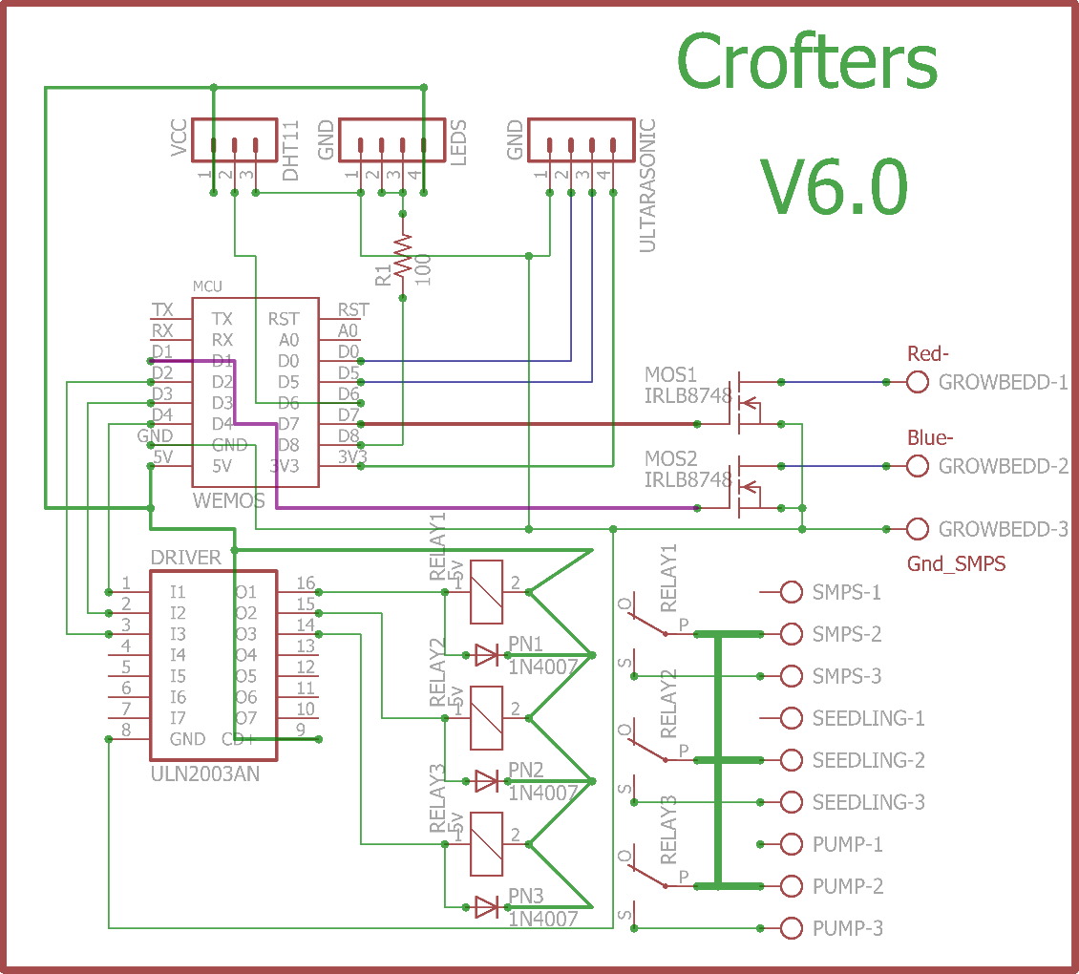

**PCB Layout**

**Top Layer**

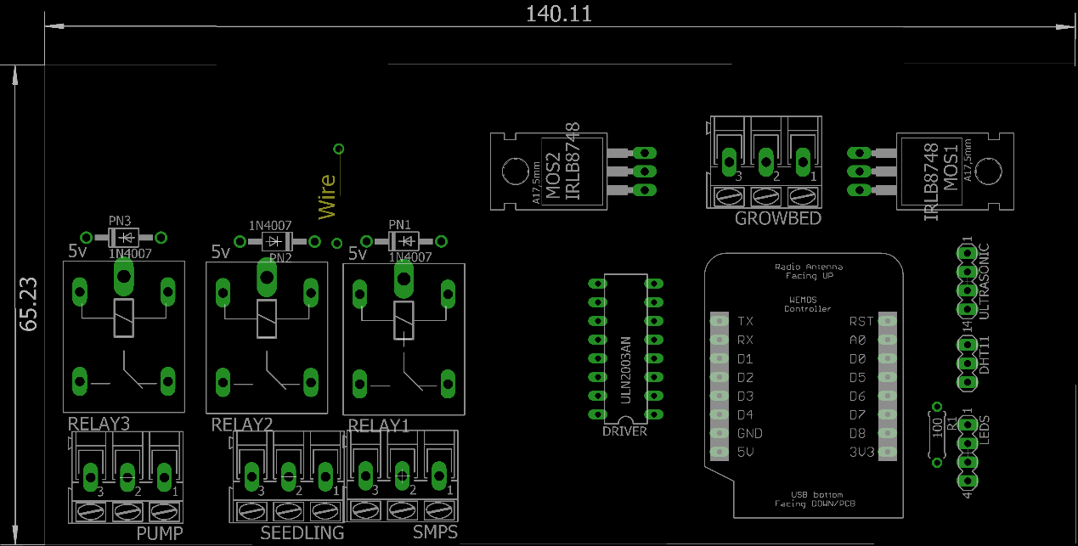

**Bottom Layer**

